Small Modular Reactors in North America
A Balanced Research Positioning: Where SMRs Earn a Place Beside Solar and Storage
Prepared as an industrial energy production & civil planning research brief
Scope: Feasibility, safety evidence, power density, deployment timeline, and sector adoption outlook
Prepared by Zackary Jackson, with the help of Perplexity and Anthropic
September 13, 2026

Core position: SMRs are not a substitute for solar, wind, and battery storage. They are a conditional, longer-lead source of clean, firm, high-density power that may become commercially proven in the early-to-mid 2030s — valuable specifically where continuous, concentrated load and site constraints make variable renewables insufficient on their own.

Index
1. Executive Summary | 1
2. The Case For SMRs | 1
3. The Case Against SMRs | 2
4. Safety: What the Evidence Actually Shows | 3
5. Power Density & Cost: The Physics and the Economics | 4
6. Deployment Timeline: When SMRs Become Probable | 4
7. North American Examples | 5
8. When to Use Solar + Storage, and When to Consider an SMR | 6
9. Industry Adoption Outlook | 7
10. Recommendations — A Layered Portfolio | 8
11. References | 9

1. Executive Summary
Small modular reactors (SMRs) sit at the center of a genuine, evidence-based debate about how North America should build clean, reliable electricity capacity through the 2030s. This brief presents the strongest case for SMRs and the strongest case against them, side by side, and then translates both into a practical planning framework: what to build now, what to develop for later, and how solar-plus-storage and SMRs fit together rather than compete.
The evidence supports a conditional conclusion, not a verdict. SMRs are technically credible — passive safety systems, a licensed first-of-a-kind project under construction in Ontario, and a regulator-approved design path all exist today. But SMR economics remain unproven at scale: published techno-economic analysis puts first-of-a-kind advanced SMR costs well above current solar, wind, and even existing-nuclear benchmarks, and the entire commercial case depends on repeat orders driving costs down a learning curve that has not yet been demonstrated in the West.
Working position: deploy solar, wind, storage, demand flexibility, and existing-nuclear life extension now for near-term capacity; develop SMR sites, licenses, and supply chains now for a probable 2031–2035 commercial proof window; and reserve SMRs for load profiles — continuous, high-density, reliability-critical — that variable renewables alone cannot economically serve.

2. The Case For SMRs
The affirmative case rests on four pillars: design-level safety improvements, power density, firm 24/7 output, and a factory-production model that — if it works — could shorten nuclear's historically long build cycles.

2.1 Passive, design-based safety
Modern SMR designs lean on passive safety: gravity-fed cooling, natural circulation, and stored water that do not require powered pumps or immediate operator action during upset conditions. The U.S. Nuclear Regulatory Commission describes GE Hitachi's BWRX-300 — the design licensed for Ontario's Darlington site — as a natural-circulation, passively-cooled boiling-water SMR. Smaller reactor cores also carry a smaller radioactive inventory per unit than a traditional large reactor, which narrows the physical consequences of a given fault.

2.2 Power density: concentrated output from a small footprint
Nuclear generation, including SMRs, delivers roughly one to two orders of magnitude more power per square meter of project footprint than solar or wind (see Section 5, Figure 1). That density matters where land, transmission corridors, or brownfield space are constrained — retired coal sites, existing nuclear campuses, and industrial parks with limited acreage.

2.3 Continuous, dispatchable output
A 300 MW SMR running near a 90% capacity factor delivers roughly 2.37 TWh per year of largely weather-independent output. That profile is structurally different from solar or wind, which require storage or backup to cover nights, calm periods, and seasonal troughs. For loads that must run continuously — heavy industry, hyperscale data centers, hospitals, military installations — firm output has a reliability value that a MWh of solar energy alone does not fully capture.

2.4 A credible, licensed North American proof point
Ontario Power Generation's Darlington New Nuclear Project is no longer a paper study. Canada's nuclear regulator (CNSC) issued a construction license for the first BWRX-300 unit on April 4, 2025, valid through March 31, 2035. OPG's plan is to finish construction and connect the first unit to the grid by the end of 2030, with three further units bringing the site to roughly 1,200 MW. This is the clearest real-world test of whether the SMR model can be licensed, built, and repeated in a Western regulatory environment.

2.5 Where the factory-production thesis could pay off
- Multi-unit sites (like Darlington's four-unit plan) that reuse the same workforce, documentation, and supply contracts across units.
- Retired coal sites with existing grid interconnection, water access, and a trained industrial workforce.
- Remote, islanded, or military microgrids where diesel logistics are costly and reliability is paramount.
- Large, durable industrial and data-center loads that value 24/7 clean power over multi-decade offtake horizons.

3. The Case Against SMRs
The skeptical case does not dispute the physics of passive safety; it disputes the economics, the timeline, and the risk of treating early announcements as an operating fleet.

3.1 Cost: first-of-a-kind is not the mature price
A 2024 DOE-sponsored techno-economic analysis of advanced multi-module SMR plants estimated overnight capital costs of roughly $3,985–$4,844 per kW and levelized costs of energy around $80.6–$89.6 per MWh — well above typical utility-scale solar and onshore wind benchmarks, and above the cost of extending the life of existing large reactors (see Figure 2). Idaho National Laboratory's first-of-a-kind versus nth-of-a-kind (FOAK/NOAK) modeling shows just how sensitive these numbers are to financing structure, interest rates, and construction discipline — meaning today's cost estimates carry real uncertainty in both directions.

3.2 The learning curve is a forecast, not a delivered result
Darlington's own budget assumes Unit 4 will cost roughly 33% less than Unit 1 (about C$4.1 billion versus a C$7.7 billion first unit, inside a C$20.9 billion four-unit program). That is a reasonable planning assumption, grounded in shared infrastructure and repeat fabrication — but it remains unproven until Units 2–4 are actually built on budget. A systematic literature review of SMR economics identifies financing risk, cost uncertainty, and thin market structure as the primary open problems, not reactor physics.

3.3 Modularity does not remove the hard problems
A 2025 Sandia/DOE study on modularization and physical protection found that factory-built modules introduce new transport, security, and site-assembly requirements rather than eliminating field complexity. “Modular” shifts where the work happens; it does not make nuclear-grade fabrication, qualified welding, inspection, and security simple.

3.4 Site-specific economics can fail outright
An IAEA case study of SMR deployment in West Kalimantan, Indonesia found that under baseline assumptions, SMR economics did not beat coal because of high upfront investment cost — the result flipped only with a roughly 10% capital-cost reduction or a meaningful carbon price. The lesson generalizes: SMR viability is market- and policy-specific, not universal.

3.5 Speed mismatch with urgent demand
The U.S. Department of Energy notes that hyperscale data-center interconnection requests commonly run 300–1,000 MW with lead times as short as one to three years. A first-of-a-kind SMR, by contrast, is a years-long licensed construction project (Darlington's first unit: roughly five years from license to planned connection). SMRs cannot be the near-term answer to demand that is arriving in the next one to three years — solar, storage, demand flexibility, and existing-asset uprates are structurally faster.

3.6 Readiness is broader than the reactor design
The OECD Nuclear Energy Agency's SMR Dashboard evaluates first-of-a-kind deployment across licensing, siting, financing, fuel supply, waste handling, and stakeholder readiness — not reactor technology alone. A design can be technically mature while the surrounding deployment ecosystem (financing structures, supply chains, workforce, waste pathway) is not.

4. Safety: What the Evidence Actually Shows
Safety claims for SMRs should rest on specific design features and regulatory findings, not on the word “small” alone. The documented evidence:
- Passive cooling: the NRC characterizes the BWRX-300 as a natural-circulation, passively-cooled water reactor — accident response relies less on powered pumps or immediate operator action.
- Smaller radioactive inventory per unit, which can reduce the thermal and radiological consequences of a given fault compared with a large single reactor core.
- Regulator-approved, risk-informed emergency planning: the NRC's 2023 rulemaking allows a scalable emergency-planning zone for advanced reactors based on design-specific hazard analysis — this tailors planning, it does not eliminate it.
- Independent licensing review: the CNSC's construction license for Darlington Unit 1 followed a formal regulatory review process, not a vendor self-certification.
What the evidence does not yet show: an operating fleet-wide safety record for Western Gen-IV/SMR designs, since no BWRX-300 or comparable advanced SMR is yet operating commercially in North America. Safety claims for SMRs are currently a design-and-regulatory-review case, not yet an operating-history case — that distinction matters for how confidently either side of this debate should speak.

5. Power Density & Cost: The Physics and the Economics
Two figures anchor the technical comparison: how much power each technology delivers per unit of land (power density), and what that power currently costs (LCOE). Both matter for planning — density shapes where a technology fits; cost shapes whether it should be built at all, and when.
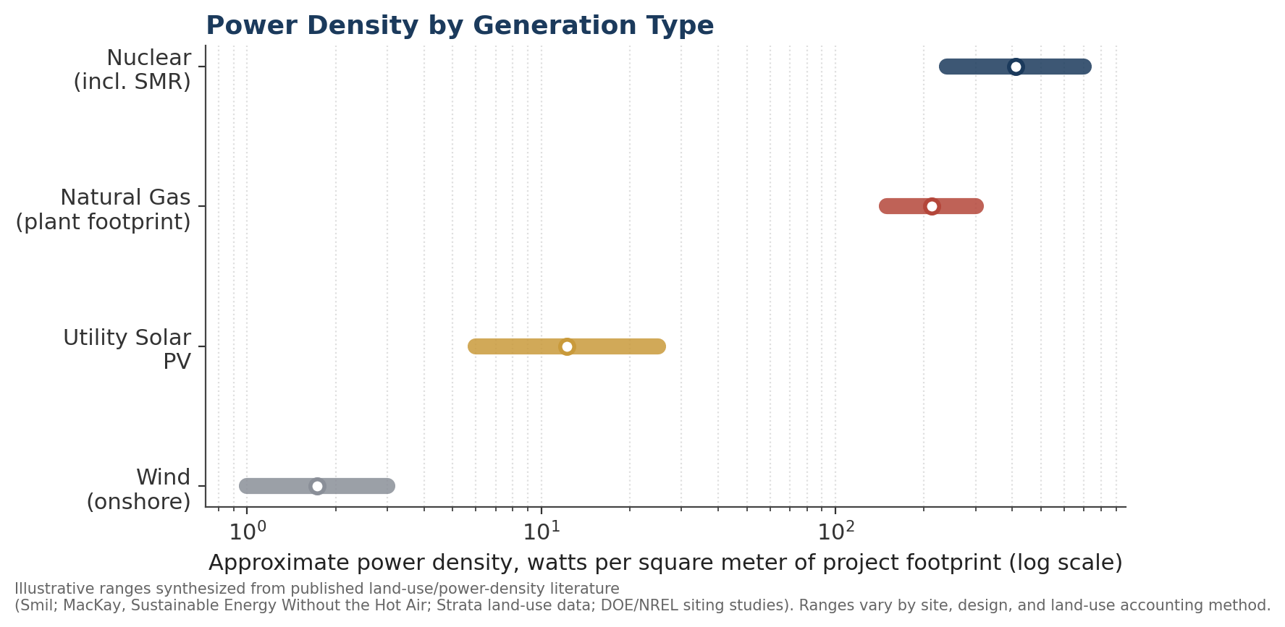
Figure 1. Nuclear (including SMRs) delivers roughly 10–100× more power per square meter than solar or wind, reflecting the energy density of fission versus diffuse renewable flux.
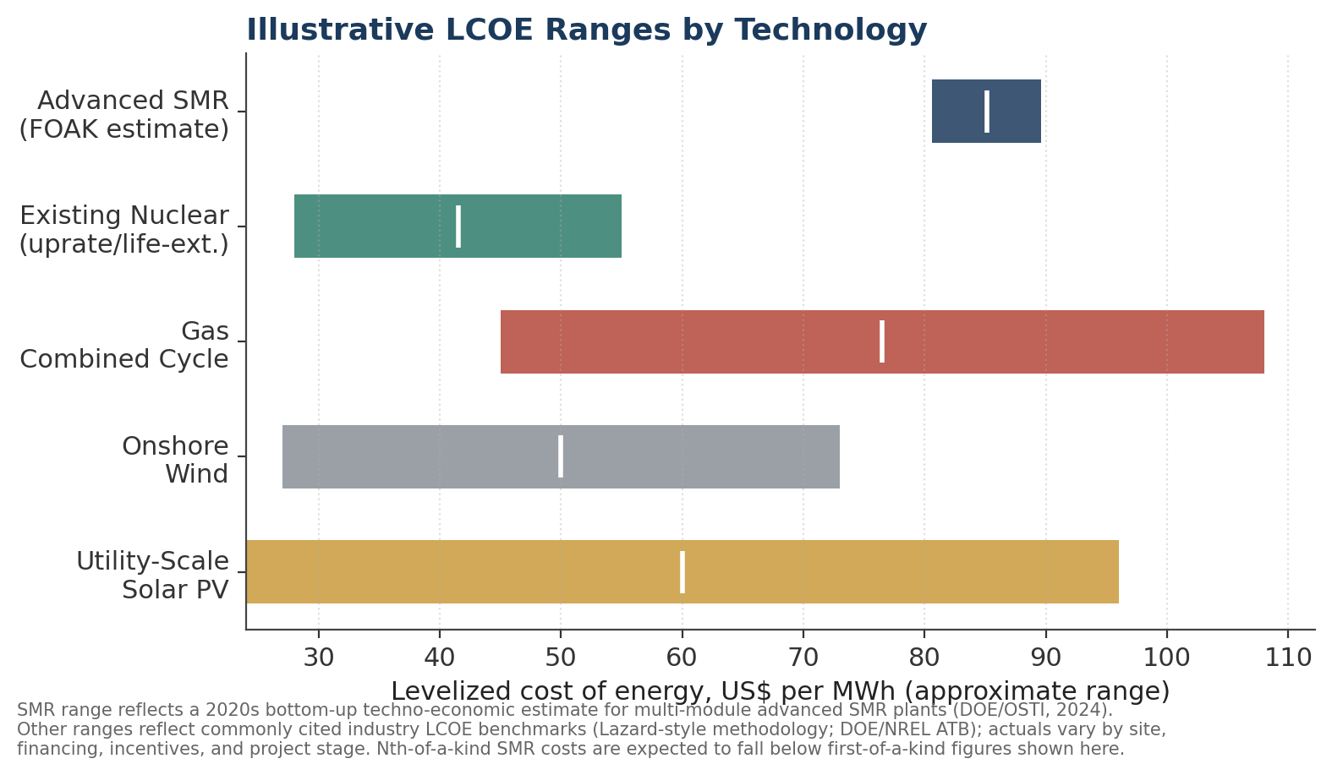
Figure 2. First-of-a-kind advanced SMR costs currently sit above solar, wind, gas, and existing-nuclear life-extension benchmarks; the commercial case depends on nth-of-a-kind costs falling substantially, as Darlington's own Unit 4 budget assumes.
Reading these two figures together explains the core tension in the SMR debate: SMRs win decisively on land-use efficiency and dispatchability, but currently lose on cost per delivered MWh. Whether that trade is worth making depends entirely on how much a given load values firm, dense, 24/7 power — which is a site-specific and sector-specific question, addressed in Sections 6–8.

6. Deployment Timeline: When SMRs Become Probable
SMRs are not a 2020s solution to near-term demand growth. Based on OPG/CNSC public milestones and DOE/NEA commentary on deployment sequencing, a defensible timeline looks like this:
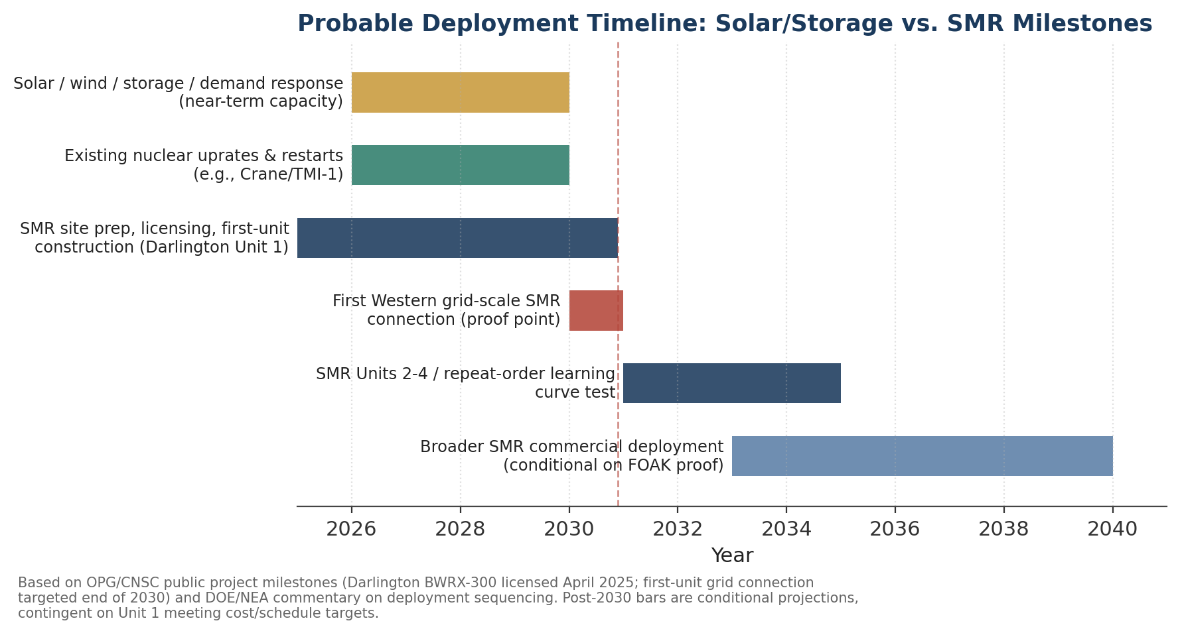
Figure 3. Solar, storage, and existing-nuclear life extension carry the 2026–2030 demand wave; Darlington's first unit is the key 2030 proof point; broader commercial SMR deployment is conditional on that proof holding through Units 2–4.
Window | What is probable | What remains conditional
2026–2030 | Solar, wind, storage, demand response, and existing-nuclear uprates/restarts meet most new demand. SMR site prep, licensing, and Darlington Unit 1 construction proceed. | Whether Darlington Unit 1 holds its cost and schedule target through 2030.
2030–2032 | First Western grid-scale SMR connection (Darlington Unit 1, targeted end of 2030) becomes the industry's reference case. | Whether the connection happens near budget and on schedule.
2032–2035 | Units 2–4 at Darlington test the repeat-order learning curve directly. | Whether unit cost actually falls ~33% as budgeted; whether other North American utilities commit to follow-on orders.
2035+ | If FOAK proof holds, SMRs become a credible clean-firm option for utility fleet replacement, industrial process heat, and large load clusters. | Overall market size, financing structures, and fuel/waste pathways at scale.

7. North American Examples

7.1 Darlington New Nuclear Project (Ontario) — the SMR proof point
- Technology: GE Hitachi BWRX-300, ~300 MW boiling-water SMR with passive safety systems.
- Status: Construction license issued by the CNSC, April 4, 2025 (valid through March 31, 2035).
- Scale: One unit initially; four units planned for ~1,200 MW total.
- Budget: ~C$7.7 billion for the first unit including common infrastructure; ~C$20.9 billion for all four units. Unit 4 is budgeted at roughly C$4.1 billion — about 33% below Unit 1.
- Target: First-unit grid connection by end of 2030.

7.2 Crane Clean Energy Center, formerly Three Mile Island Unit 1 (Pennsylvania) — the faster alternative
This is not an SMR, and that is the point: Constellation's 20-year agreement to restart the ~835 MW Crane Clean Energy Center to serve Microsoft's data-center demand shows that restarting existing large nuclear capacity can deliver clean, firm power on a materially faster timeline than a new-build SMR. It is the clearest North American example of the “use existing assets first” half of this brief's recommended sequencing.

7.3 Retired coal and constrained industrial sites — the strategic 2030s opportunity
Across the U.S. and Canada, retired or retiring coal plants offer existing grid interconnection, water rights, transmission capacity, and a trained industrial workforce — exactly the site characteristics that reduce SMR development risk. These sites are widely discussed in DOE and utility planning as leading candidates for first-mover SMR siting once Darlington's proof point is established, though few have reached construction-license status.

8. When to Use Solar + Storage, and When to Consider an SMR
The two technologies solve different problems. Solar and batteries are the fastest, cheapest tools for adding bulk low-carbon energy and shaving peaks; SMRs are a slower, costlier, but denser and more continuous tool for firm capacity where the load profile and site genuinely require it.
Decision factor | Favors solar + battery storage | Favors considering an SMR
Timeline to power | Need capacity within 1–3 years | Load or site horizon is 7+ years out
Load shape | Daytime-weighted, or shiftable/flexible load | Continuous 24/7 baseload with low tolerance for interruption
Land availability | Ample land, rooftop, or brownfield space nearby | Land- or footprint-constrained site (urban-adjacent, industrial campus)
Site legacy | Greenfield or distributed sites | Retired coal plant or existing nuclear campus with grid/water infrastructure already in place
Risk tolerance / financing | Smaller, modular, replicable project financing | Access to long-term offtake contracts, regulated cost recovery, or public-sector backing
Carbon/reliability value | Standard grid, moderate reliability premium | High reliability premium, or a jurisdiction pricing carbon meaningfully
Project count needed | One project stands on its own economically | Multiple follow-on units needed to reach commercial viability (learning curve)

In practice, most large loads — especially data centers — will end up on a hybrid path: solar and storage for daytime energy and peak support, demand flexibility to shift shiftable compute, transmission upgrades for market access, and either existing-nuclear power purchase agreements now or an SMR offtake contract for the 2030s to cover the firm, continuous residual load.

9. Industry Adoption Outlook
No credible quantitative market forecast for SMR adoption by sector exists yet, because no commercial fleet is operating. The chart below is a directional index — not a MW or market-share forecast — built from the pattern of announced pilots, siting studies, and offtake discussions reported by DOE, the NEA, and utility/hyperscaler announcements.
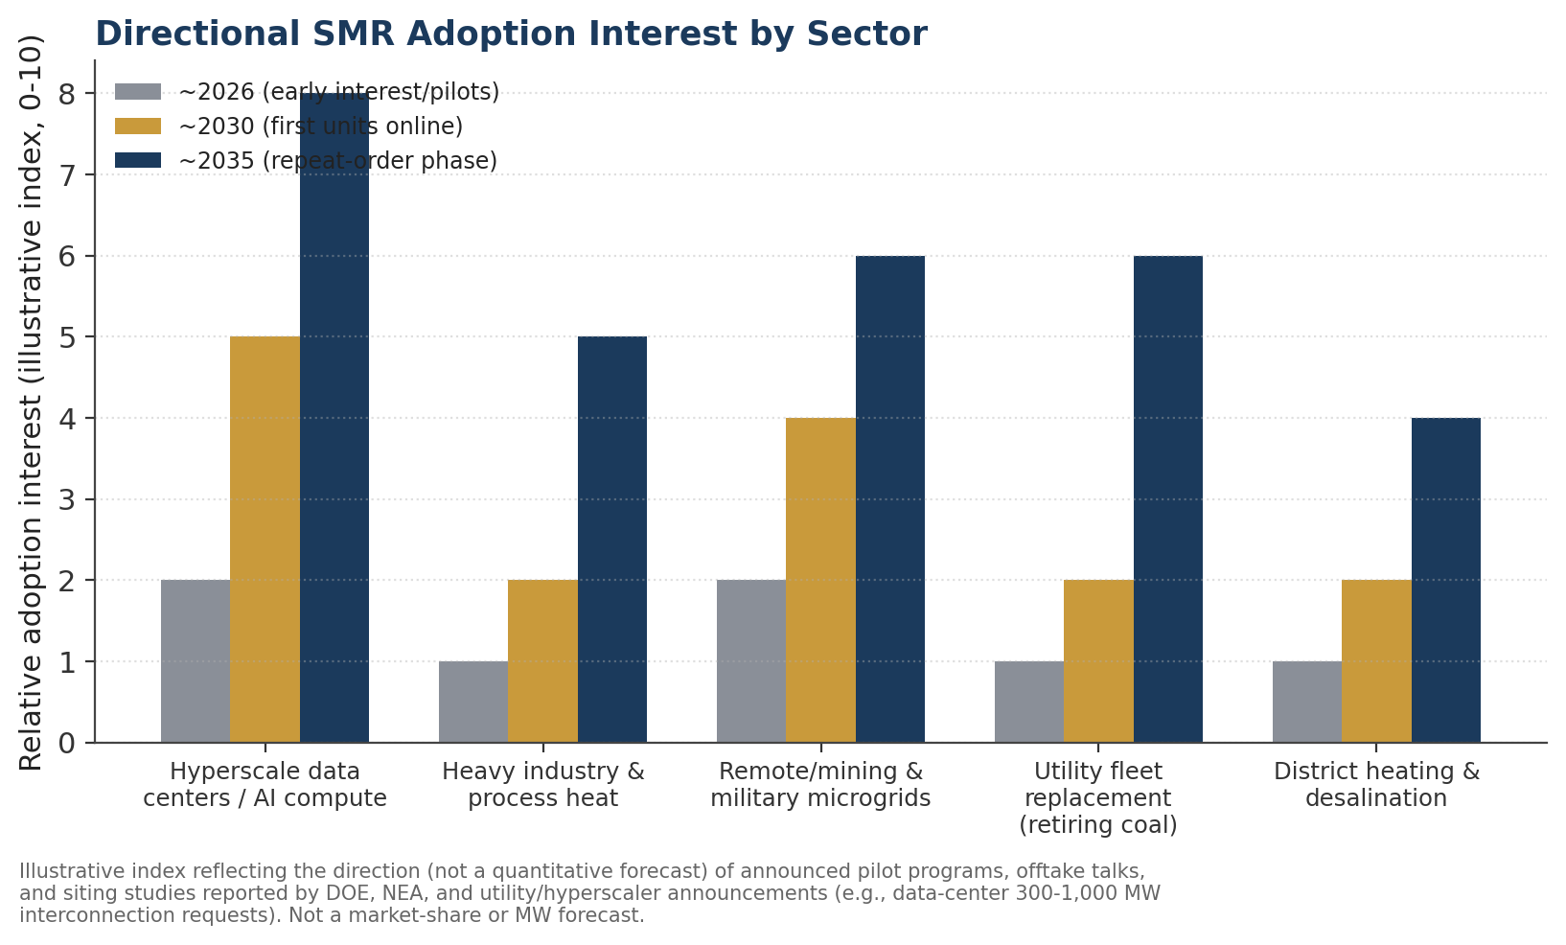
Figure 4. Hyperscale data centers and remote/military microgrids show the earliest and steepest directional interest; heavy industry and utility fleet replacement follow once a Western operating track record exists.

9.1 Sector notes
- Data centers / AI compute: largest and most time-urgent demand growth (DOE cites 300–1,000 MW interconnection requests); near-term needs are met by solar/storage/existing nuclear, with SMR offtake positioned as a 2030s option for durable load clusters.
- Heavy industry & process heat: process-heat applications value continuous thermal/electric output; adoption likely trails data centers because process retrofits and financing take longer to structure.
- Remote, mining & military microgrids: high value for SMRs where diesel logistics are expensive and reliability is mission-critical, though project scale is smaller than a Darlington-class site.
- Utility fleet replacement (retiring coal): a strategic, longer-horizon opportunity contingent on Darlington-style proof of cost and schedule discipline.
- District heating & desalination: smallest near-term signal in North America; more active in some international SMR programs.

10. Recommendations — A Layered Portfolio
- Deploy solar, wind, batteries, demand response, efficiency, and grid/transmission upgrades now to meet 2026–2030 demand growth — these remain the fastest, lowest-cost tools available.
- Preserve and extend existing nuclear capacity (restarts, uprates, license extensions) as the fastest source of additional firm, clean power this decade — the Crane/TMI-1 restart is the model.
- Develop SMR sites, licenses, supply chains, and offtake agreements now, without treating any of it as delivered capacity before Darlington's first unit actually connects.
- Treat Darlington Unit 1 (targeted end of 2030) as the decision-relevant proof point for the entire North American SMR thesis, and Units 2–4 as the real test of the cost-learning curve.
- Target SMRs specifically at retired coal sites, existing nuclear campuses, remote/military microgrids, and large durable data-center or industrial clusters — not as a general-purpose grid resource.
- Do not let SMR planning delay solar, storage, or transmission investment; do not treat early SMR announcements as a delivered operating fleet.

11. References
Government, regulatory, and national-laboratory sources
- Canadian Nuclear Safety Commission (CNSC), construction license authorization for OPG's Darlington BWRX-300, April 2025.
- Ontario Power Generation (OPG), Darlington SMR project page and public statements.
- Government of Canada, Major Projects Office, Darlington New Nuclear Project profile.
- U.S. Nuclear Regulatory Commission (NRC), BWRX-300 pre-application materials; Emergency Preparedness Rulemaking for advanced reactors (2023).
- U.S. Department of Energy (DOE), Office of Nuclear Energy, “Benefits of Small Modular Reactors”; DOE, “Powering AI and Data Center Infrastructure Recommendations,” July 2024.
- Idaho National Laboratory / OSTI, First-of-a-Kind and Nth-of-a-Kind (FOAK/NOAK) SMR economic analysis.
- OSTI / DOE, techno-economic analysis of advanced small modular reactors (2024).
- Sandia National Laboratories / DOE, modularization and physical-protection feasibility study (2025).
- OECD Nuclear Energy Agency, SMR Dashboard (Second Edition).
- International Atomic Energy Agency (IAEA), cost-benefit case study of SMR deployment, West Kalimantan, Indonesia.
Industry and news reporting
- World Nuclear News, coverage of Darlington's four-unit budget and per-unit cost breakdown.
- Constellation Energy, announcement of the Crane Clean Energy Center (Three Mile Island Unit 1) restart agreement with Microsoft.
General physics and economics benchmarks
- Land-use and power-density literature synthesizing figures widely cited in energy-systems analysis (e.g., Václav Smil's energy-density work; David MacKay, Sustainable Energy — Without the Hot Air; Strata and NREL/DOE siting and land-use studies).
- Levelized cost of energy benchmarks reflecting standard industry methodology and typical published ranges (Lazard-style LCOE analysis; DOE/NREL Annual Technology Baseline).
Note on figures: Figures 1, 2, and 4 present illustrative ranges and directional indices synthesized from the sources above for comparative purposes; they are not a substitute for site-specific engineering or financial analysis. Figure 3 reflects publicly announced project milestones as of the source materials, with post-2030 phases shown as conditional projections.

